# Executive Summary

This report presents details of the project for a teleoperated robot trying to score in opponent’s goal and defend its own meanwhile. Remotely controlled robots are widely used in many aspects of our life. Main idea behind this project reflects a real-world problem in occasions where the user has no view of the robot. Therefore, a two-way communication with the robot and user’s computer should be established. Reliability and efficiency of this communication is vital since intervening a distant robot which can be unreachable at that instant, by the user can be challenging.

This design will be accomplished by building an efficient communication, a robust mechanical design and reliable electronic system. We aim to achieve satisfactory performance in speed and accuracy. Our final product is to detect the ball on the field, shoot the ball towards the opponent’s goal, defend its goal and stay in its half field doing so. Several solution methods are sufficiently described in the following sections of this report.

Our company is composed of five shareholders with different specialization fields and backgrounds. Therefore, each team member came up with a solution from a different point of view. We merged these perspectives in order to construct solution approaches at this point of our design process.

Mission of our company is to provide creative and reliable solutions that fulfill the needs of industry in the field of Industrial robot applications while or vision is to become the most compelling technology company by driving the Industry’s transition to smart manufacturing.

Even though our base knowledge is similar, each team member chose to study in different fields. Therefore, at certain levels of the design process and solution offering, each member has a different idea and experience. Ms. Arabacı is more experienced in controller design and system modelling which will help her to guide and inform the team, Ms. Coşkun and Mr. Göksu will lead the team with their programming skills. Mr. Beyenir’s knowledge in electronics will help us in the integration stage and last but not least Mr. Elik will take an active role in building a durable and stable communication system.

Final product will be delivered in best way with a cost of 200$, at the end of 7 months by PITECH engineers. Once the customer purchases the final product, they will own the final action robot consisting of mechanical subsystems, camera, sensors and drivers. In addition to these, a user manual, a warranty document, required software tools, four batteries, battery chargers, three game field walls, two balls (one is extra) and a dummy robot are also provided.

# Introduction

In the last few decades, robots are gaining more complex abilities, thanks to improvements of technology, that they substitute for humans in many fields of industry. This progress enables us to handle things easier and, in more time, efficient way since their performance is better than ours in many aspects of our daily life such as personal, professional life etc.

Being a newly founded company with five highly motivated, young engineers from different specialization fields such as electronics, control, computer and telecommunications; our aim is to develop a teleoperated robot that can play hockey which includes trying to score in opponent’s goal and also defend its own goal. Apart from the specifications defined above we intend to come up with the best featured robot possible.

In this project, our main purpose is to build a robot that we can control from a specified distance with a remote controller. Also, this robot should be controlled without actually monitoring the play-field with naked eye; the only means of monitoring the field is by means of a camera mounted onboard the robot. Wi-Fi connection is not allowed for transmission, that is the reason why we are using RF communication to transmit the data. In addition to that, the robot is not allowed to cross the center-line into opponent’s half-field. Another requirement is that the ball must be transferred to opponent’s half-field in no more than 20 seconds.  Robots can hit, push or otherwise drive the ball but not grasp, scoop or otherwise carry it.

In order to fulfill these requirements, we found an efficient way to transfer data from our robot to the main computer so that we can improve our chance to score a goal and win the round. This is a two-way communication since we will send directions to the robot so that it can move with respect to these commands. In addition, the mechanical structure of the robot should also be robust so that it can endure possible encounters with the ball. While developing the design, it should be noted that both mechanical and electrical solutions support each other. To sum up, this project and its solutions may contribute to the areas where teleoperated robots are used for many different purposes.

In this report, a detailed analysis of the final form of this project is presented. Description of overall system and subsystems is presented in this report. In addition to that, drawings, block diagrams, flow charts, test results, cost analysis, time plan can be found in following sections of this report. Also, deliverables, user manual, information about budget and discussions can be found in the following sections.

# Fkjahga

# Results and Analyses of Performance Tests

## Subsystem Tests

### Power Subsystem Test and Results

To comply with the power requirements power tests are conducted. First test was to measure current values under full load conditions. We measured the robot side draws 3.4 Amperes under full load conditions (going forward with full speed while transmitting video). Through related calculations this corresponds approximately 23 minutes of operations with our 1350 mAh Li-Po battery. Even though this result complies with the requirement that has been mentioned in the earlier reports we want operation longer that 23 minutes. On the other hand, this calculation made under the assumption of the system always runs under full load conditions which is not the case under real life conditions. Since our robot is not going to be move all the time with full speed our expected battery life is more than 81 minutes. Under no load conditions (when our robot is not moving but video transmission is available) our robot draws less than 1.5 Ampere. Under no load condition this result gives us 54 minutes of operation. So, if we assume that our robot works under full load conditions 50% of the time we will have approximately 38 minutes of operation on the robot side. To conclude if we assume that one match will take approximately between 10 to 15 minutes, our robot can play 2 to 3 games without the need of recharging.

This test was also made with demonstration. We played a game with an opponent for 10 minutes of time after we fully charged our battery. After 10 minutes, we checked our battery with our Li-Po battery charger and observed that we only used 30% of our battery. This result verified our prior calculations.

The same tests are also conducted for teleoperator side. Teleoperator side has 900 mAh battery. Teleoperator draws approximately 1.5 Amperes. Teleoperator’s power rating does not change significantly so this value used for our calculations. With this current rating our 900 mAh Li-Po battery gives us 36 minutes of operation. When we conduct the test with demonstration after 10 minutes of operation we observed that also 30% of teleoperator’s battery has been used.

To analyze these results, we can say that we offer our customer approximately 35 minutes of operation without the need of recharging. This value can be increased with the use of higher capacity batteries. However, since batteries are important costs of the robot it was a tradeoff. Customer can buy higher capacity batteries if they need to. Since, we assumed it will be sufficient to play 2 to 3 games for an average customer we used these batteries. Also, since the capacity is smaller they charge faster. So, at the end these battery values were most suitable for our case.

# Deliverables

As Potato Integrated Technologies, providing creative and reliable solutions to our customers is a matter of paramount importance for us. To accomplish the highest customer satisfaction, we provide high quality robotic solutions specified for the problem. Therefore, the final product that is going to be served to the customer is guaranteed to satisfy our policy of quality.

Our customers will receive a complete delivery of the main unit, auxiliary equipment, documentations and software. The robot unit, auxiliary equipment, documents and software that are going to be in the delivery packet are summarized below.

**Main Unit:** This package contains the main unit; the robot unit which will take a part in a competition where it tries to score to the opponents’ goal protect its goal. Our final product will be send fully attached only thing that the customer should do is to connect batteries to the main system. Figure 5.1 below shows the main unit that is going to be send to the customer.

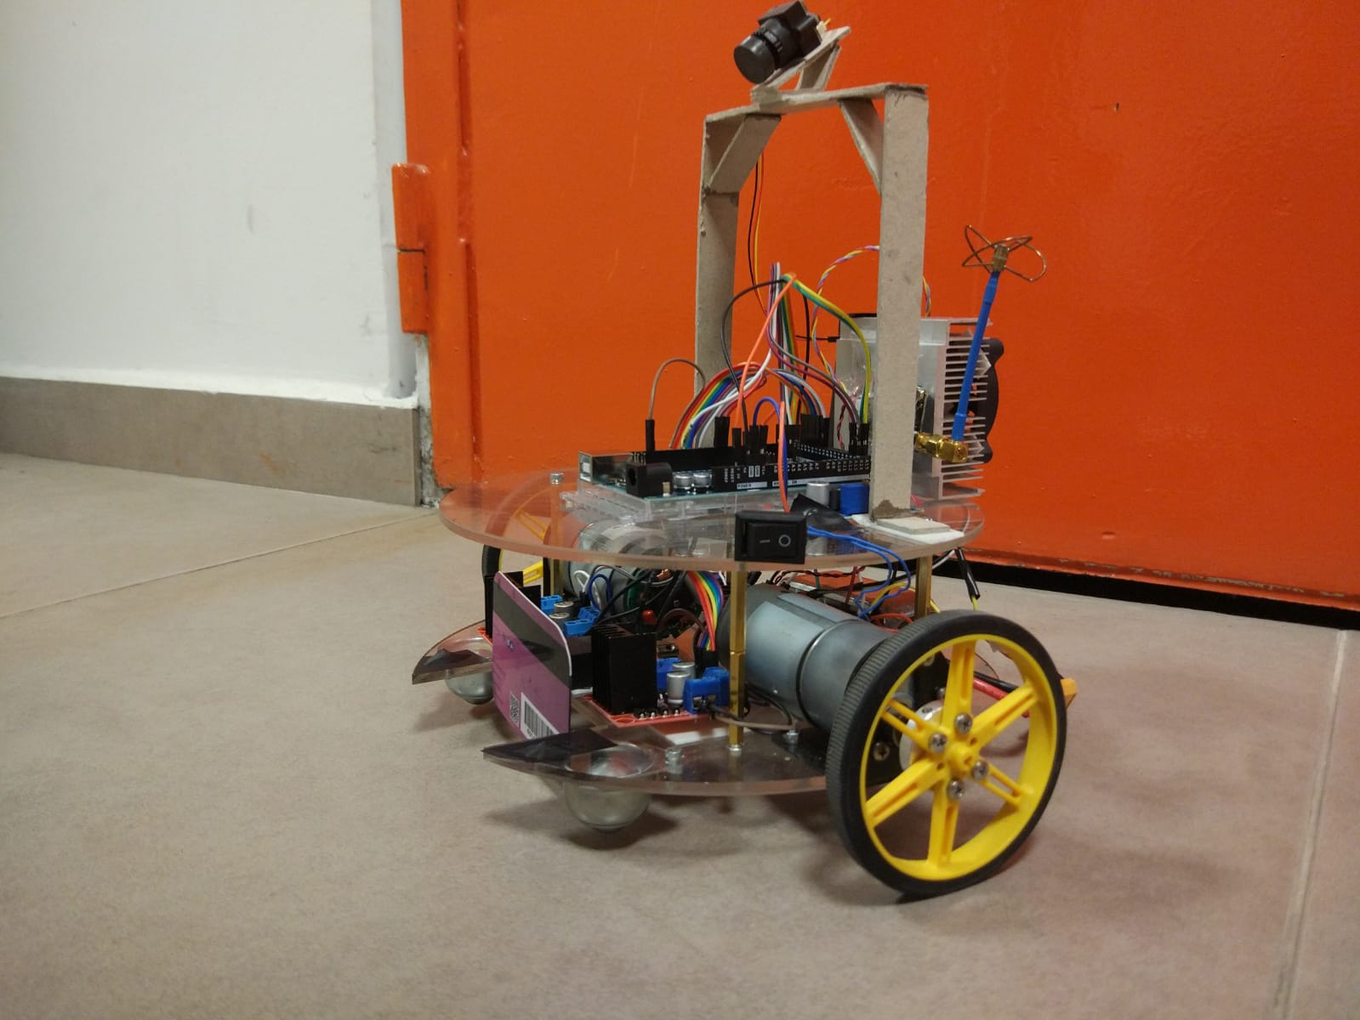

Figure 5.1: Main unit

**Teleoperator:** A controller unit which the operator going to use for teleoperate the robot unit is going to be delivered to the customer. This part will have a screen mounted on it in order to display the robot’s environment. A joystick will be mounted on this module to control the robot’s movements. This part will also be send fully attached except the battery. Figure 5.2 below shows the teleoperator.

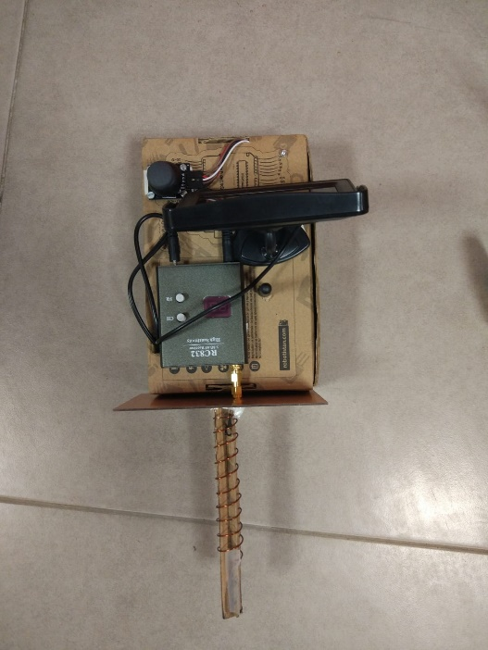

Figure 5.2: Teleoperator

**Auxiliary Equipment:** This package contains equipment necessary to fully operate the robot and build the competition environment. The pack contains; 2 Li-Po battery, 1 for teleoperator and the other for main unit, 6 Walls for game field that have tapes indicating the self-goal position, two ball (diameter 30-45 mm) (one is spare), a dummy robot (for demonstration purposes).

**Documents:** This package contains the all the necessary documents in hardcopy. This pack contains; one user manual (can also be found Appendix II), complete list of part used in the main unit and their reference codes, a 2-year warranty and a 5-year spare part support.

**Software:** This package contains a digital source of necessary documents and computer interface. The purpose of computer interface is to make necessary adjustments on the robot for different environmental conditions. The user might change the speed of the robot using this software if it is necessary. Also, digital versions of the documents can be found on the software.

# Jsgoıflk

# Jdsjkbshb

# Conclusion

The main focus of this final report is to show that our final product meets the requirements that have been mentioned in previous reports. This report showed the results and performance requirements of our final product to emphasize the fact that the final product meets the customers expectations and needs. In this report we presented our system design for the previously stated problem, “Devices Trying to Score in Each Other’s Goals”, namely a robot that communicates with the controller and via remote operator, tries to score on opponent’s goal. We clearly described our design with top-down system approach, showed results and analyses of performance tests.

We clearly justified our design decisions with related calculations and diagrams. Block diagrams and flow charts were given for visualization of the system. Moreover, individual subblock descriptions and their flow charts were presented in this report. General circuit diagram was also given.

Results and analyses of performance tests were presented in this report. These tests showed our final product meets the expectations of the final user. The contents of final product package that is going to be delivered to customer was covered in the Deliverables part.

The budget of the entire project was mentioned in two separate parts namely actual expenditures and total costs. Total costs consist of engineering and infrastructure costs in addition to the cost of final product.

This report also provides discussions on safety issues and precautions that our team take to avoid safety problems, possible widespread applications and potential environmental effects of our final product.

To conclude, this report contains all the parts of our design with clear justification. Our main goal is using the most practical and simple solution that would not create redundant complications for this product is to be used in various real-life applications. So, we Potato Integrated will deliver an exceptional final product together with the deliverables, within a short timeframe and economic budget. Our aim as an ambitious company to thrive on everyday problems with topnotch products with performance and durability.

As PITech engineers, we tried to find the best solution within $200 budget that will fulfill the requirements and satisfy the customer. This report is to shows that our system under review can proceed into system fabrication, demonstration, and tests. We are confident and showed that our design meets the stated performance requirements within cost (budget), customer needs and other system constraints.